Help our school get cash!

Supporting our school by raising funds has never been easier! You can make a difference by submitting labels and Box Tops from foods you already use. Your friends and family can pitch in too! Box Tops for Education, Labels for Education and Tyson Project A+ are terrific programs that are easy and rewarding for our school! Join the fun!



Let’s party with Box Tops! Submit Box Tops and your class could win a Box Top party from the SLWK8 PTO! The Elementary and Middle School classes that bring in the most Box Tops are awarded a gift card

every nine weeks!

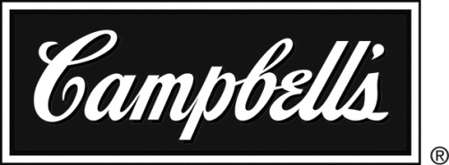 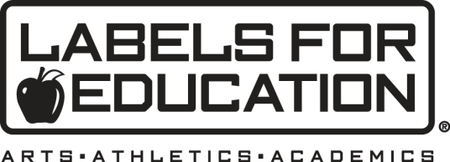

**Clip labels from these participating products and our school earns funds to purchase items we need!**

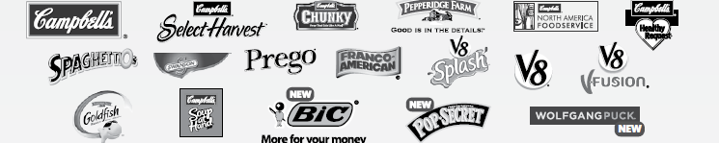

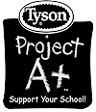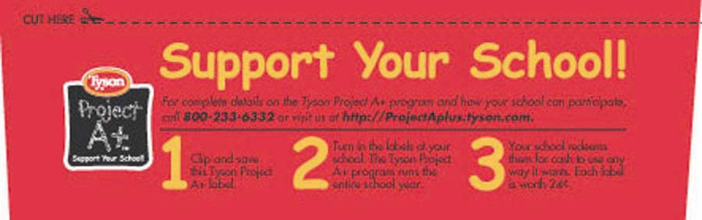

**Clip Tyson food labels and get cash for our school!**

**Submit Box Tops and labels in clearly marked packaging, marked with the teacher name, to the office in the PTO box. Please separate Box Tops, Campbell’s labels, and Tyson labels. Thanks!**